Grid (Raster)

***What is this?***

A grid is a skeleton that can be used to produce completely different looks and its primary purpose is to create clarity and consistency on the page, without using floats and positioning.

What’s inside the grids?

The grid layout consists of margins as well as columns and alleys. Vertical columns and horizontal rows are building blocks of the grids, and an area in between two columns and two rows is called an alley or a gutter.

***Its elements…***

Grid has a layout with a parent-element and one or more child-elements.

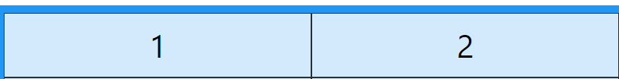

<div class="grid-container">  
  <div class="grid-item">1</div>  
  <div class="grid-item">2</div>  
</div>

***How to make the display property in CSS?***

An HTML element becomes a grid container when its display property is set to **grid**or **inline-grid.**

Grid containers consist of grid items, placed inside columns and rows.

.grid-container {  
  display: grid;  
}

***Child-elements...***

* Become grid items
* Vertical lines are columns (GRID COLUMNS)

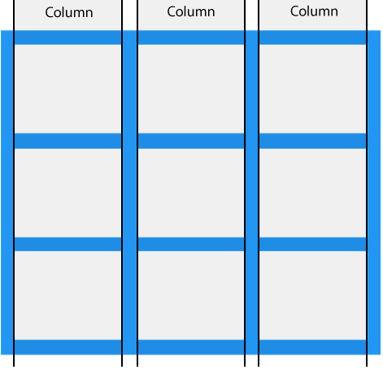

.grid-container {  
  display: grid;  
**column-gap: 50px;**  
}

* Horizontal lines are rows (GRID ROW)

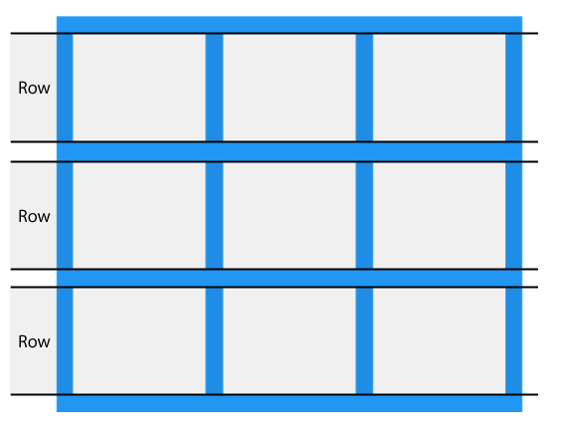

.grid-container {  
  display: grid;  
**row-gap: 50px;**}

* The lines between columns are called column lines.

The lines between rows are called row lines.

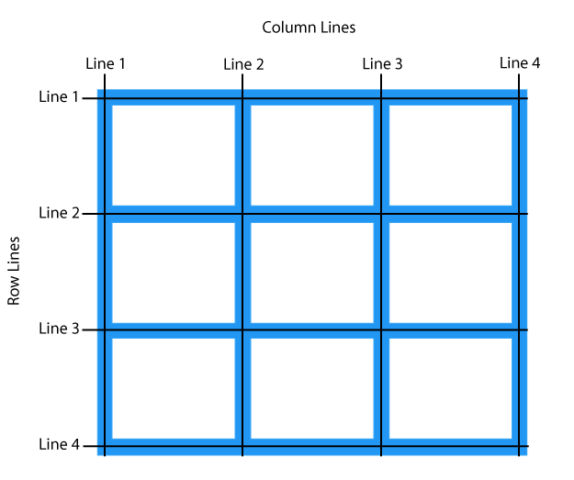

.item1 {  
grid-row-start: 1;  
  grid-row-end: 3;  
}

.item1 {  
grid-column-start: 1;  
  grid-column-end: 3;  
}

***How to use justify-content here?***

* The justify-content property is used to align the whole grid inside the container.



.grid-container {  
  display: grid;  
  justify-content: space-evenly;  
}

***How to use align-content here?***

The align-content property is used to *vertically* align the whole grid inside the container.



.grid-container {  
  display: grid;  
  height: 400px;  
  align-content: center;  
}

***STEFI FUSHAJ***

***2ax***